ASSIGNMENT IS DUE 11/01/2020 BY 11:30!!!!

https://nku.instructure.com/courses/33385/assignments/519119?module_item_id=1287003

The above link is to my canvas page.

The class is marketing 300, listed under my courses as “Marketing tools (2020 fall)”

Marketing Tools (2020 Fall)
The above link is for the course

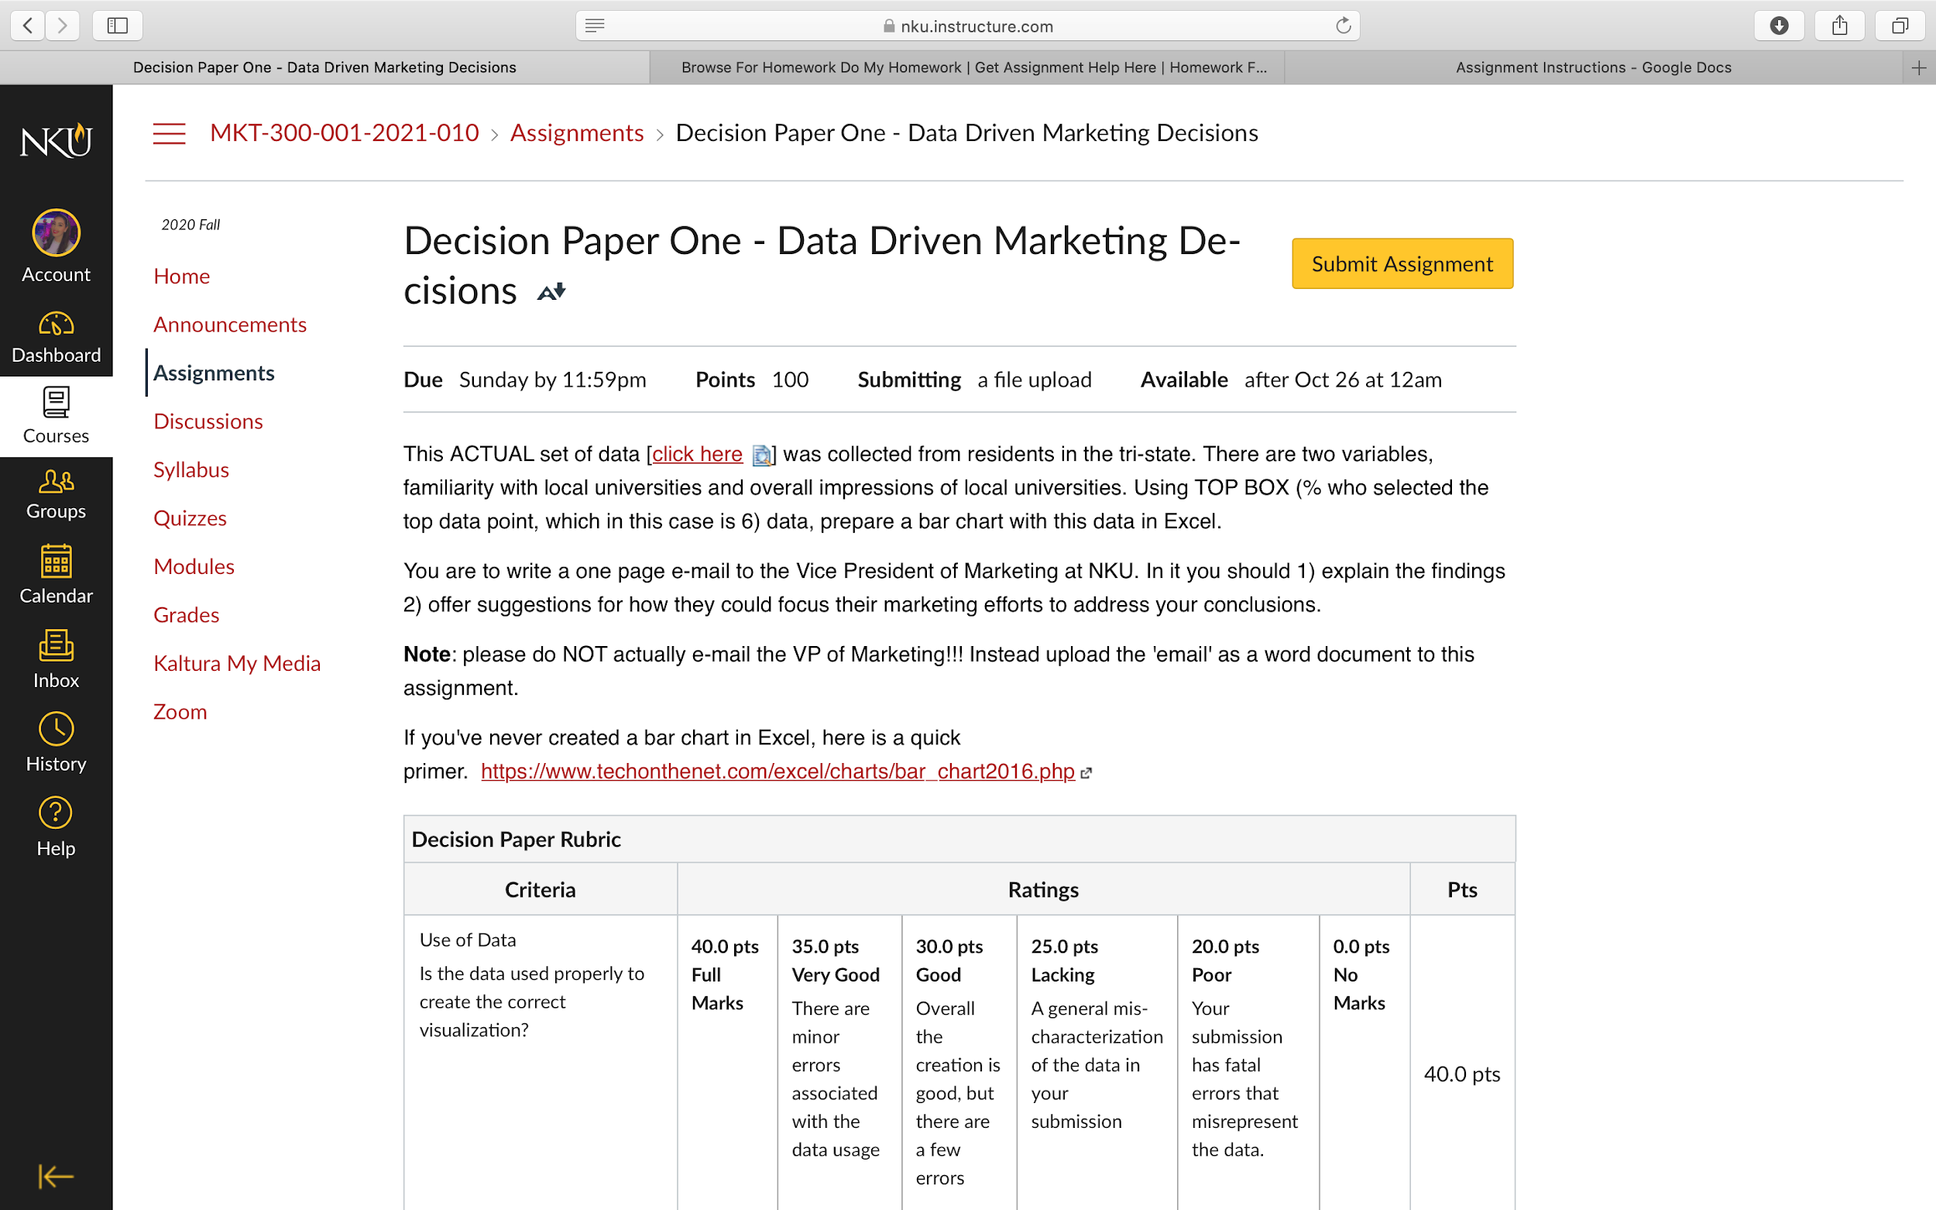

Screenshot of the assignment

Username: daherl1
Password: Nanouna15!

The above username and password is the login for canvas.

